**Jenkins Integration with maven:**

To integrate Jenkins with maven, first you need to download the maven on the EC2 machine. You can download from we using either Curl or wget command.

Then uzip the .gz bundle using tar –xvzf

Now if you go inside the unzip folder then there is a bin directory, inside this there is maven binary. Now if you want to execute any maven command you can run inside this directory.

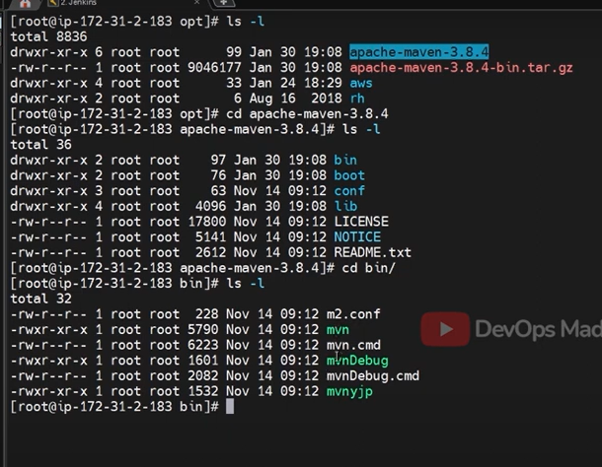

You can add maven path to system path env variable so that commands can be run without ./mvn –version.

In order to integrate maven with Jenkins we need to set below 2 variables in

manage Jenkins🡪 configure system and set below 2 variables.

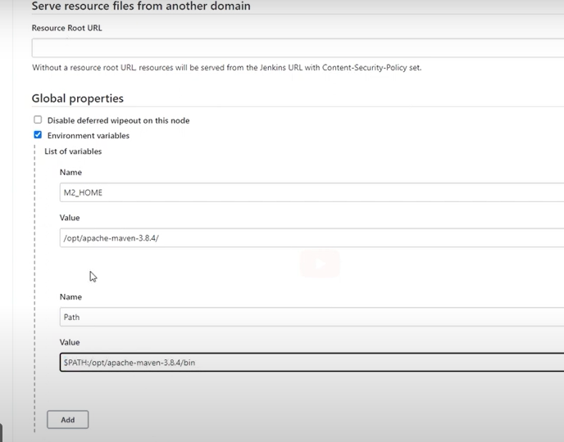

If you want to have multiple maven versions ,then you can define under Manage Jenkins🡪 global tool configuration.

Then navigate to maven installations 🡪 add maven.